**Project 5: Shaders**

**Screenshots**

**Stationary Vertex Shader Pattern:**

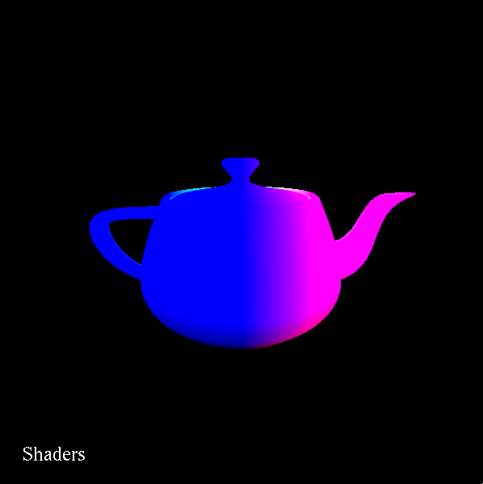

**Animated Vertex Shader Pattern:**

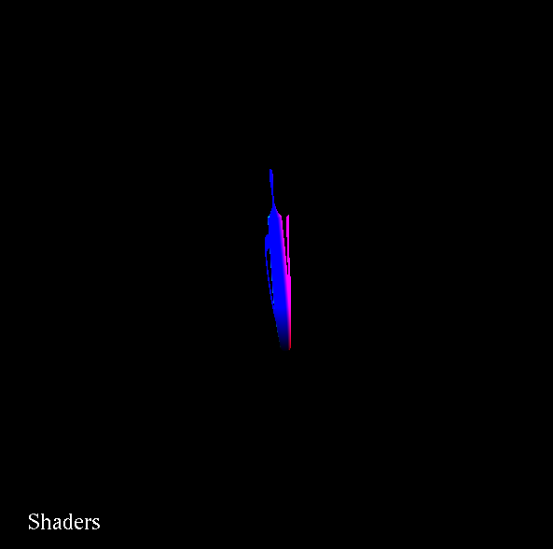

**Stationary Fragment Shader Pattern:**

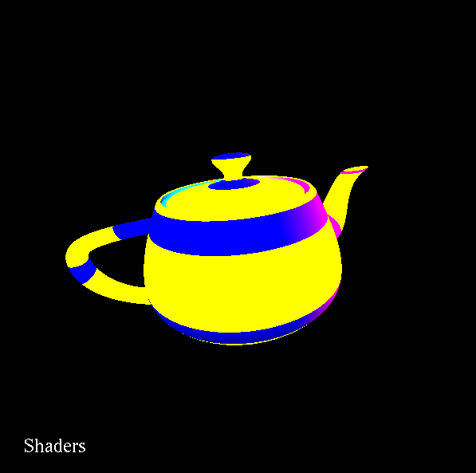

**Animated Fragment Shader Pattern:**

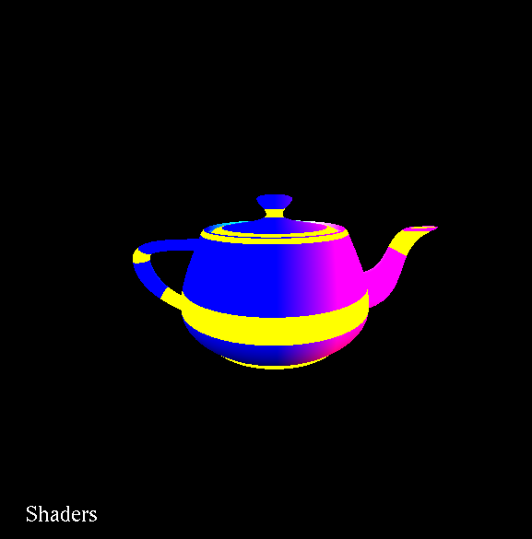

**Both Together:**

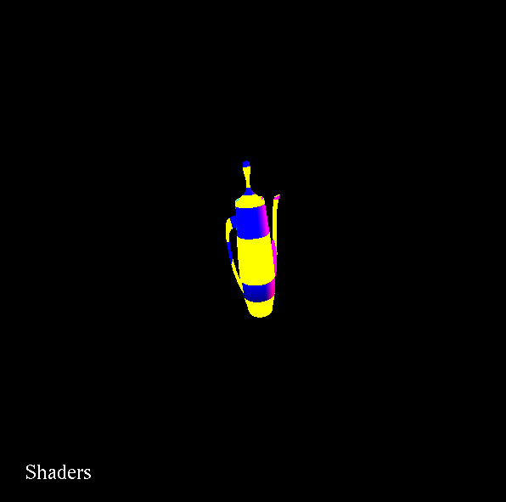

**Youtube Video Link:**

[**https://www.youtube.com/watch?v=T_Tg4SpyJqA&feature=youtu.be**](https://www.youtube.com/watch?v=T_Tg4SpyJqA&feature=youtu.be)